# **Sales Automobile Using Salesforce CRM**

## **1. Project Overview**

The Salesforce CRM implementation for automobile sales is designed to streamline and optimize the entire sales process. This project addresses key challenges in the automotive industry, such as lead management, inventory tracking, and personalized customer engagement, by leveraging Salesforce's powerful CRM capabilities. The goal is to enhance operational efficiency, improve customer satisfaction, and drive revenue growth. Salesforce CRM supports automotive businesses in a competitive market by fostering better customer relationships, automating workflows, and providing actionable insights through analytics.

## **2. Objectives**

### **Business Goals:**

* **Optimize Sales Processes:** Automate routine sales tasks, enhance lead tracking, and improve follow-ups to reduce delays and manual errors.
* **Enhance Customer Engagement:** Provide personalized marketing strategies and targeted campaigns to improve customer retention.
* **Improve Decision-Making:** Use insightful analytics and reporting to identify trends, forecast demand, and make data-driven decisions.
* **Enable Seamless Communication:** Integrate marketing tools to facilitate communication and lead nurturing across multiple platforms.

### **Specific Outcomes:**

* **Customer Profiling:** Enable comprehensive profiling for targeted marketing.
* **Inventory Management:** Ensure real-time updates on available vehicles and specifications.
* **Automation:** Streamline processes like lead assignment, service reminders, and follow-ups.
* **Data Insights:** Empower sales managers with trends, KPIs, and forecasts through dashboards and reports.

## **3. Salesforce Key Features and Concepts Utilized**

* **Sales Cloud:** Centralized lead and opportunity management to enhance sales pipeline visibility and customer interactions.
* **Marketing Cloud:** Tools for creating personalized campaigns and managing customer journeys.
* **Inventory Management:** Real-time tracking of vehicle stock levels, specifications, and availability.
* **Workflow Automation:** Automates repetitive tasks such as follow-ups and service reminders.
* **Reports and Dashboards:** Customizable real-time insights for identifying trends and monitoring KPIs.
* **Customization with Salesforce Lightning:** Provides a tailored user interface to meet the unique needs of the automotive sales process.

## **4. Detailed Steps to Solution Design**

### **Step 1: Creating a Developer Account**

1. Navigate to [Salesforce Developer Signup](https://developer.salesforce.com/signup).
2. Fill out the form with the following details:
   * First Name & Last Name
   * Email Address
   * Role: Developer
   * Company: Your College Name
   * Country: India
   * Postal Code: Your pin code
   * Username: A unique username in the format username@organization.com.
3. Click **Sign Me Up**.
4. Activate the account via the verification email and set up a password.

### **Step 2: Creating Objects**

#### **Automobile Information Object**

1. Download and save the "AutomobileInformation.csv" file.
2. Navigate to Setup > Object Manager > Create > Custom Object from Spreadsheet.
3. Upload the CSV file and verify field mappings.
4. Save and finish the object creation process.

#### **Invoice Object**

1. Repeat the process for the "Invoice" object, ensuring proper field mappings.

#### **Opportunity Automobile Object**

1. Go to Object Manager > Create > Custom Object.
2. Enter the following details:
   * **Label Name:** Opportunity Automobile
   * **Plural Label Name:** Opportunity Automobiles
   * **Record Name:** Opportunity Automobile ID
   * **Data Type:** Auto Number
   * **Display Format:** OA-{0000}
   * **Starting Number:** 1
3. Enable reports and search for the object, then save.

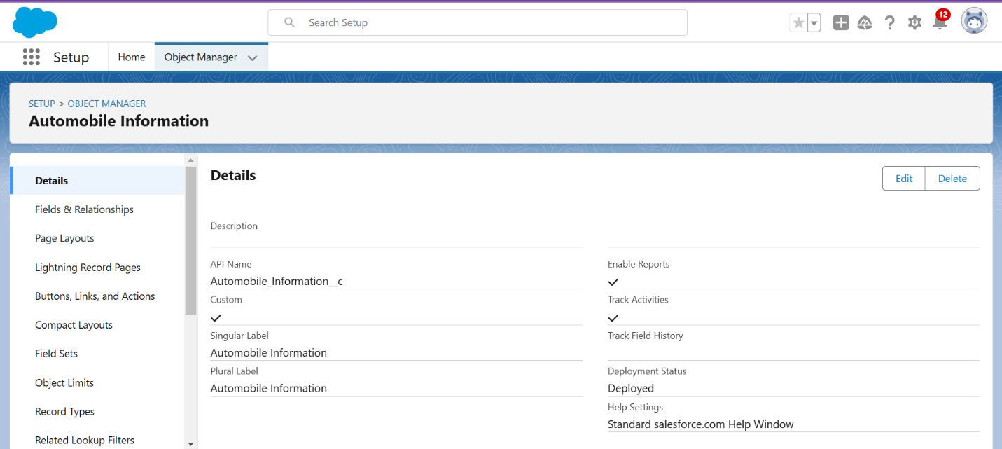

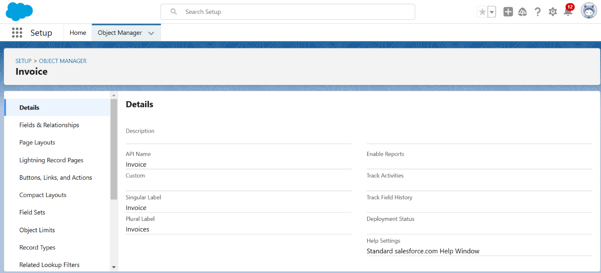

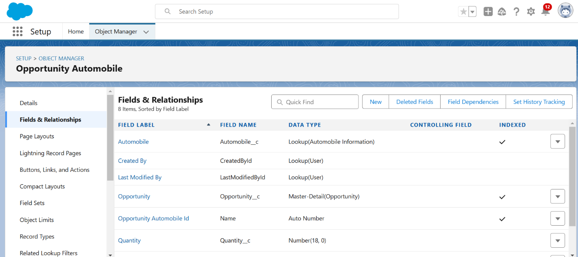

### **Step 3: Creating Tabs**

1. Navigate to Setup > Tabs > Custom Object Tabs > New.
2. Select the object (e.g., Opportunity Automobile).
3. Choose a tab style and click Next.
4. Add the tab to the desired profiles and apps, then save.

### **Step 4: Creating Fields & Relationships**

#### **Master Detail Relationship Field**

* **Object:** Opportunity Automobile
* **Data Type:** Master-Detail Relationship
* **Field Label and Name:** Opportunity

#### **Lookup Relationship Field**

* **Object:** Opportunity Automobile
* **Data Type:** Lookup Relationship
* **Field Label and Name:** Automobile

#### **Number Field**

* **Object:** Opportunity Automobile
* **Field Label:** Quantity
* **Data Type:** Number (Required)

#### **Formula Fields**

* **Field 1:**
  + **Label and Name:** Unit Price
  + **Data Type:** Formula (Currency)
  + **Formula:** Automobile__r.Price__c
* **Field 2:**
  + **Label and Name:** Total Price
  + **Data Type:** Formula (Currency)
  + **Formula:** Unit_Price__c * Quantity__c

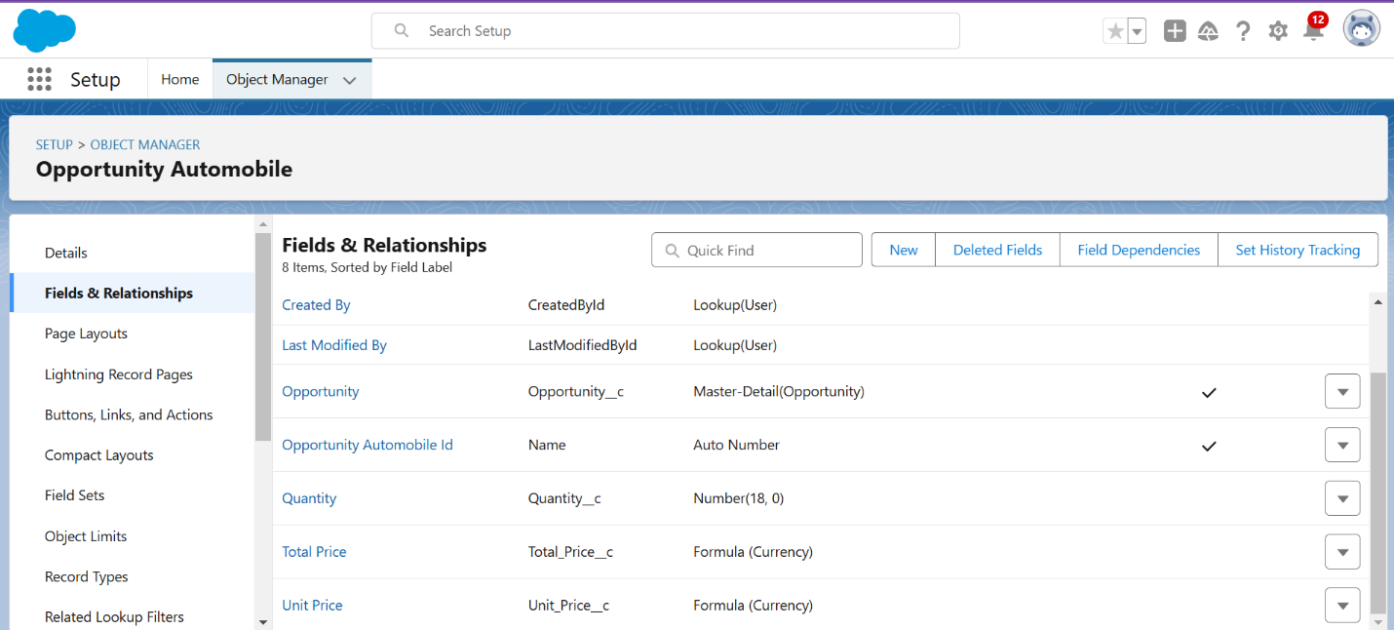

### **Step 5: Editing Page Layouts**

#### **Opportunity Object**

1. Navigate to Setup > Object Manager > Search for Opportunity > Page Layouts.
2. Select "Opportunity Layout."
3. In the Opportunity Detail Section, locate the "Account Name" field.
4. Click the Properties icon for the field, mark it as Required, and save.

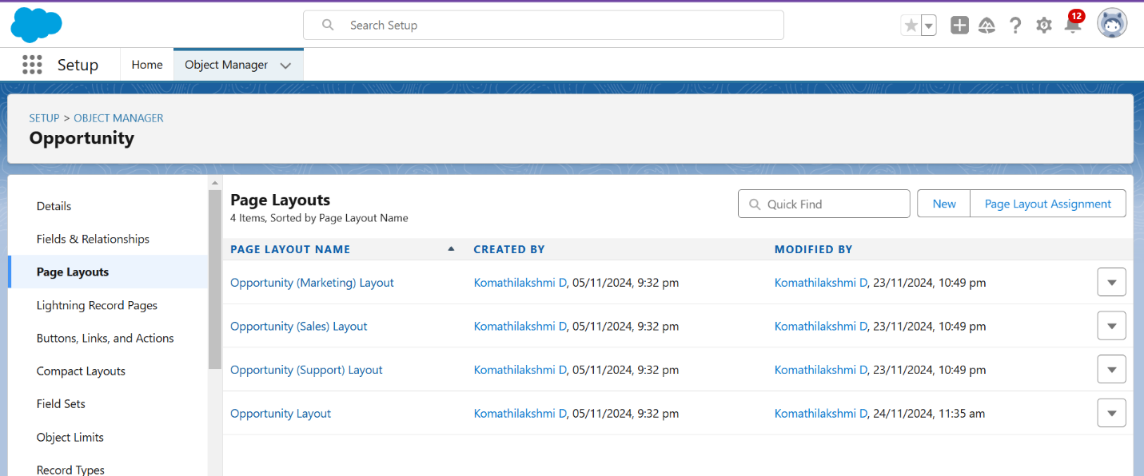

#### **Automobile Information Object**

1. Navigate to Setup > Object Manager > Search for Automobile Information > Page Layouts.
2. Select "Automobile Information Layout."
3. Mark necessary fields as Required and adjust the layout for better organization.
4. Save the changes.

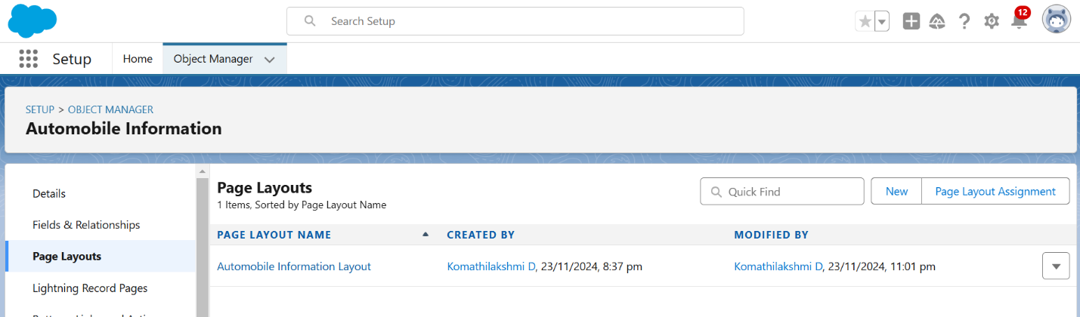

## **5. Testing and Validation**

### **Unit Testing**

* Validate functionality of Apex classes, triggers, and automated processes.
* Ensure CRUD operations and business logic are correctly implemented.
* Achieve at least 75% code coverage for all Apex components.

### **User Interface Testing**

* Verify that the UI components work as expected and that navigation is intuitive.
* Test customer profiles, inventory management, and technician dashboards.
* Ensure role-based access controls are correctly enforced.

## **6. Key Scenarios Addressed by Salesforce**

### **Scenario 1: Lead Management**

* **Challenge:** Tracking and converting leads efficiently.
* **Solution:** Centralized lead storage with automated follow-ups.

### **Scenario 2: Inventory Tracking**

* **Challenge:** Ensuring real-time vehicle availability.
* **Solution:** Automated inventory updates and alerts for low stock levels.

### **Scenario 3: Personalized Marketing**

* **Challenge:** Delivering targeted campaigns.
* **Solution:** Customer profiling and journey tracking through Marketing Cloud.

### **Scenario 4: Apex Triggers for Automation**

#### **Use Case 1: Opportunity-Automobile Quantity**

* **Scenario:** When an opportunity is marked as "Closed Won," reduce the quantity of the associated automobile in inventory.
* **Solution:**
  + Create an Apex Trigger ("OpportunityTrigger") and a handler class ("OpportunityHandlerClass").
  + The trigger ensures inventory updates are automated based on opportunity status.

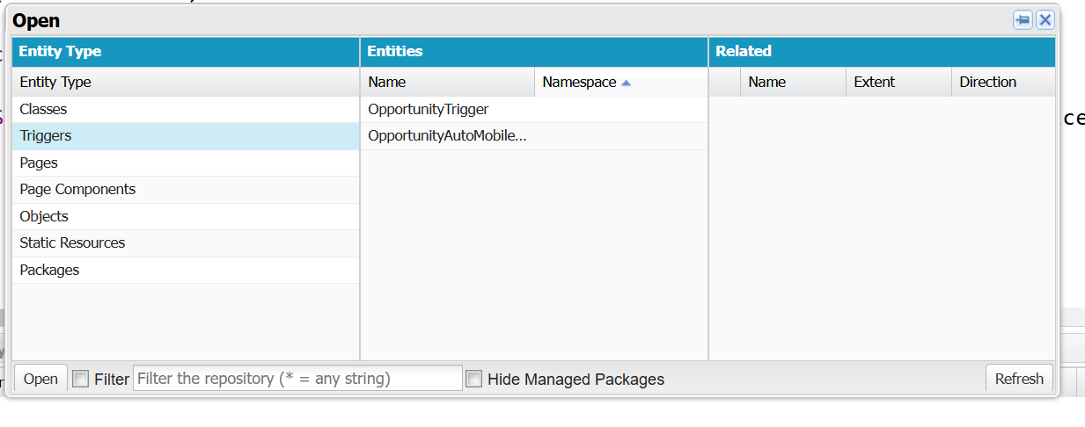

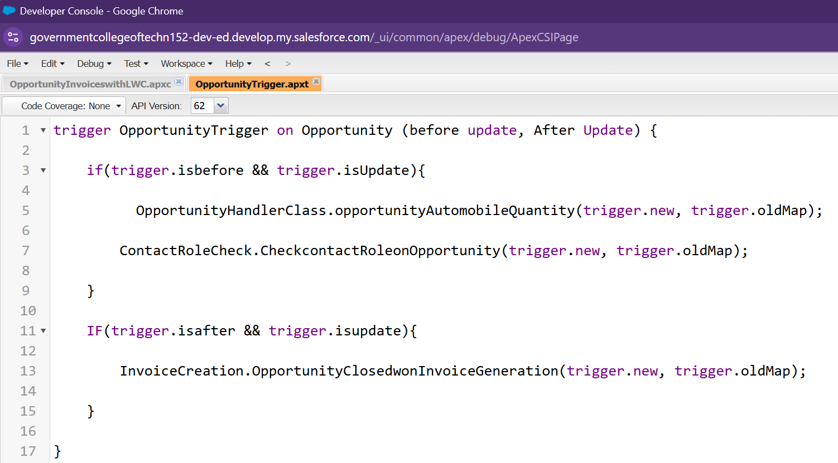

#### **Use Case 2: Opportunity-Automobile Error Handling**

* **Scenario:** Prevent the assignment of a quantity exceeding available stock.
* **Solution:**
  + Create a trigger and handler class to validate stock availability and throw an error if insufficient stock exists.

#### **Use Case 3: Invoice Creation**

* **Scenario:** Automatically generate an invoice when an opportunity is marked as "Closed Won."
* **Solution:**
  + Use the "InvoiceCreation" class to automate the creation of invoices based on Opportunity-Automobile data.

#### **Use Case 4: Contact Role Validation**

* **Scenario:** Ensure that every "Closed Won" opportunity has an associated contact role.
* **Solution:**
  + Implement a trigger to check for contact roles and throw an error if missing.

## **7. Conclusion**

The Salesforce CRM implementation for automobile sales successfully enhances efficiency, customer satisfaction, and revenue generation. Through streamlined processes, real-time analytics, and automation, the platform empowers sales teams to achieve their goals while fostering long-term customer relationships.